Report Title

Student ID

(DO NOT put in your Student Name)

(Feel free to modify this title page. Just ensure you include the information above)

Contents

List of Tables 3

List of Figures 3

Part 1 - Introduction 4

Section 1 Heading 4

Section 2 Heading 4

Part 2 – Main Body of text (change this heading – don’t leave it as is) 5

Section 1 Heading 5

Section 2 Heading 5

Section 3 Heading 5

Part 3 – Conclusion (change this heading – don’t leave it as is) 6

Section 1 Heading 6

Section 2 Heading 6

Section 3 Heading 6

References 7

Quick guide to creating references in Microsoft Word 7

Other notes 8

(this part is optional – if you have tables/figures in your document)

## List of Tables

Table 1 - Interesting Stuff 4

Table 2 - More interesting stuff 4

## List of Figures

Figure 1 - Local Employer RBK 4

Figure 2- a random picture 5

Figure 3 - Entering reference sources 7

Figure 4 - New Source 7

Figure 5 - Source type 8

Figure 6 - Using a source as a reference in your document 8

## Part 1 - Introduction

### Section 1 Heading

Introduce the context for your report here. Think of it as “setting the scene” for what you are going to talk about and the relevance of the topic. Part 1 would *ideally* be in and around 1,000 words

### Section 2 Heading

You can explore it a bit more here, perhaps go into a little detail about what is to come and possibly make reference to work that is already done in this subject area.

The picture below gives you an example of how you can insert diagrams/pictures in your report and give them a title, such as “Figure 1”



Figure 1 – Athlone Institute of Technology

## Part 2 – Main Body of text (change this heading – don’t leave it as is)

Part 2 would *ideall*y be in and around 3,000 words. Break this down into (possibly) 1,000 word sections and then break that down further into (say) 250 word sections. Write one section at a time, ensuring that there is flow from one section to the next, and from one part of the document to the next.

### Section 1 Heading

In here, lead up to your discussion in more detail.

Another example of a figure/diagram/photo. Note how the text “*Figure 2*” is entered automatically **and** is included automatically in the table of figures above.



Figure 2- a random picture

### Section 2 Heading

Continue the main argument here

If you want to insert a table, below are two examples. Again, the text “*Table 1*” and “*Table 2*” is entered automatically and included in the list of tables above. To change the caption, right-click on it.

|  |  |  |
| --- | --- | --- |
| Table of information | Column 1 | Column 2 |
| Interesting stuff 1 |  |  |
| Interesting stuff 2 |  |  |
| Interesting stuff 3 |  |  |

Table 1 - Interesting Stuff

### Section 3 Heading

And here (if needed)

|  |  |  |
| --- | --- | --- |
| Table of information | Column 1 | Column 2 |
| More Interesting stuff 1 |  |  |
| More Interesting stuff 2 |  |  |
| More Interesting stuff 3 |  |  |

Table 2 - More interesting stuff

## Part 3 – Conclusion (change this heading – don’t leave it as is)

Part 3 would *ideall*y be in and around 1,000 words. Again, 4 x 250 words would make it more manageable. Or, 2 x 300 words, plus one 400 words – whatever works for you. These are just guidelines.

### Section 1 Heading

Summarise your points here. What have you talked about?

### Section 2 Heading

Come to any conclusions, maybe you have some suggestions or recommendations, perhaps?

### Section 3 Heading

Finish up here (if needed)

## References

### Quick guide to creating references in Microsoft Word

This can be used when referencing the works of others in your main report.

This is how you **enter** a source you want to use:

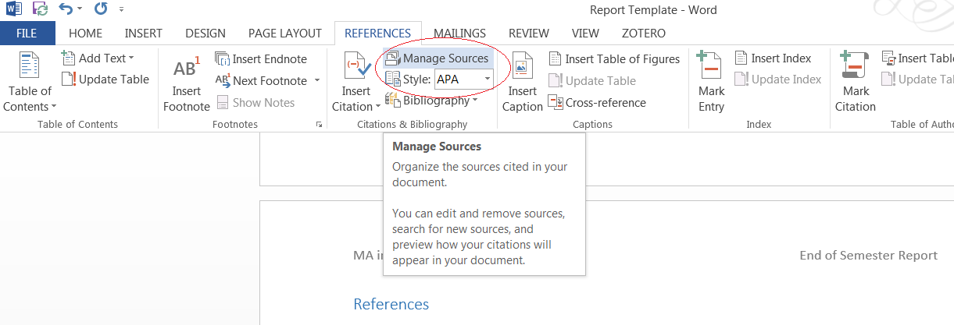

Figure 3 - Entering reference sources

When you click on “Manage Sources” above, this is what you get:

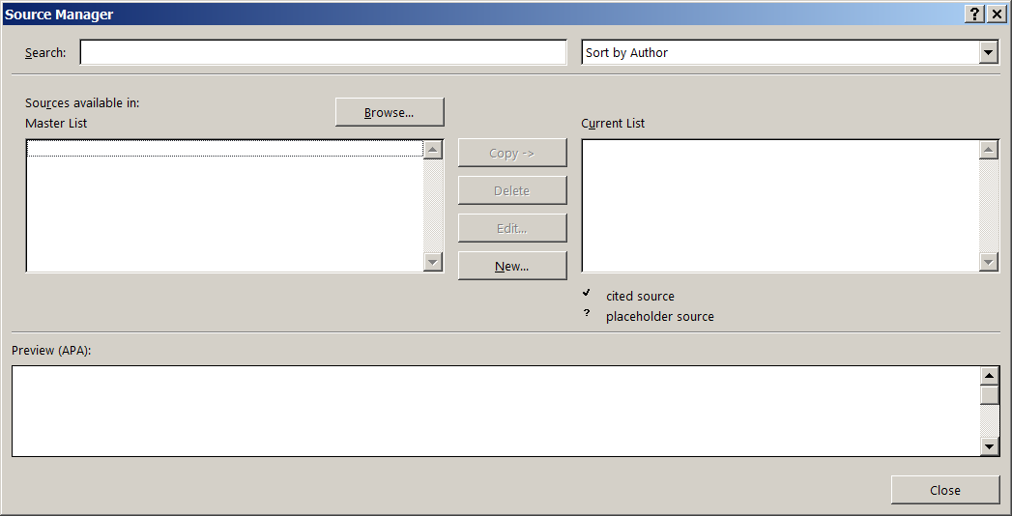

Figure 4 - New Source

(continued on next page)

Click on the “New…” button and you will see this:

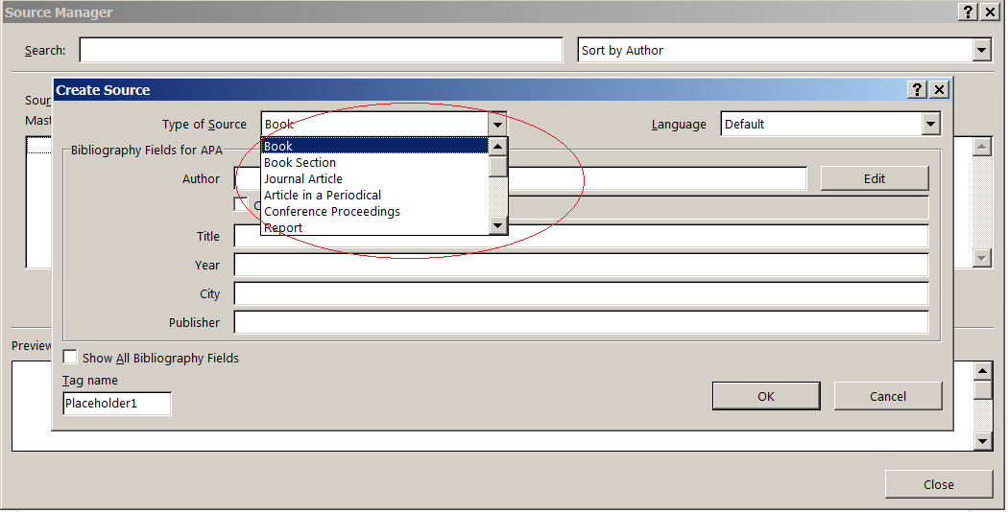

Figure 5 - Source type

When you enter source information, you can then use that source, as a reference in the main body of your text:

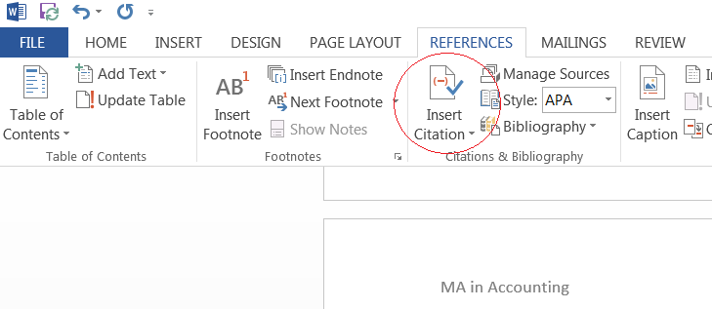

Figure 6 - Using a source as a reference in your document

In addition to entering it in the main body of the text, Microsoft Word will also automatically create a correctly formatted entry at the end of your document in the References section.